**HO CHI MINH UNIVERSITY OF TECHNOLOGY AND EDUCATION**

**FACULTY OF INTERNATIONAL EDUCATION**----------------------------



**IT PROJECT**

**BUILD A WEBSITE TO MANAGE PROJECT OF**

**IT FACULTY**

**Lecturer name**: PhD. Tran Nhat Quang

**Subject ID:** PROJ215879E

**Class:** PROJ215879E_24_1_10FIE

**List of members**

|  |  |
| --- | --- |
| **Student ID** | **Student name** |
| 19110152 | Huỳnh Gia Kiện |

Ho Chi Minh City, 11/2024

**SOCIALIST REPUBLIC OF VIETNAM**

**Independence – Freedom – Happiness**

*******

**INSTRUCTOR’S COMMENTARY**

Course name: **IT Project**

Project’s name: **BUILD A WEBSITE TO MANAGE PROJECT OF IT FACULTY**

Reviewer’s full name: **PhD. Tran Nhat Quang**

COMMENTARY:

*Ho Chi Minh, November 2024*

*Supervisor*

*(Sign, write full name)*

**Trần Nhật Quang**

**ACKNOWLEDGEMENTS**

I would like to take this opportunity to express my sincerest gratitude to my instructor, PhD Tran Nhat Quang, for his invaluable support and guidance throughout this course. His unwavering dedication to helping me succeed in my final project has been nothing short of inspiring, and I am incredibly grateful for the opportunity to learn from such a knowledgeable and experienced developer.

Furthermore, I would like to extend my heartfelt thanks to my classmates, whose contributions have been instrumental in helping me develop a strong and well-informed thesis. Their insights and feedback have been invaluable, and I am grateful for the knowledge and expertise they have shared with me.

Despite the challenges I faced, I managed to complete the subject and report in a short amount of time, with limited resources and varying levels of expertise in programming implementation. As a result, I acknowledge that there may be flaws in my work, and I welcome any constructive criticism or suggestions for improvement.

In conclusion, I would like to express my appreciation to everyone who has supported me on this journey. This final project would not have been possible without the collective effort of my instructor, classmates, and mentors, and I am truly grateful for the opportunity to learn and grow in this field. Thank you all for your support and encouragement. I welcome any feedback as well as suggestions for improving my project. I deeply appreciate it. Sincerely!

**Table of Contents**

Chapter 1: Project Specification 1

1.1. Purpose 1

1.2. Input data and information 1

1.3. Use cases 1

1.4. Expected interface 2

Chapter 2: Work Division 3

Chapter 3: System Design 4

3.1. Usecase Diagram 4

3.2. File Structures 4

3.2.1. File structures 4

3.2.2. Method applied 7

3.3. Database Design 10

3.3.1. Database design diagram 10

3.3.2. Tables in the database 10

3.4. Describing fields in tables 10

3.4.1. User table 10

3.4.2. Topic table 11

3.5. User Interface design 12

Chapter 4: Testing 16

Chapter 5: Conclusion 20

5.1. Achievements 20

5.2. Strengths and drawbacks 20

5.3. Reflection 20

5.4. Future developments 21

Chapter 6: References 22

Table of figure

Figure 1. Usecase Diagram 4

Figure 2. Front-end File Structures 5

Figure 3. Back-end File Structures 6

Figure 4. ERD Diagram 10

List of tables

Table 1. Usecase Table 1

Table 2. Work Division Table 3

Table 3. Method Applied Table 7

Table 4. User Database Table 11

Table 5. Topic Database Table 11

Table 6. User Interface Design Table 12

Table 7. Testing Table 16

# Project Specification

## 1.1. Purpose

Create a website with all the functions of a project management website that is convenient for users. Website ensures stability and security for users.

***The software will facilitate:***

* Providing an accessible and secure platform for all users to interact with project topic efficiently.

***Usage Context:***

* Students: Register project topics, view project instructor and reviewer.
* Lecturers: Register to supervise specific topics
* Deans: Approve project topics, assign reviewers and register to supervise specific topics.
* Admins: Manage users, topics.

## 1.2. Input data and information

* Login credentials (username, password).
* Students’s personal information
* Lecturers’s personal information
* Deans’s personal information
* Topics’s detail

## 1.3. Use cases

Table 1. Usecase Table

|  |  |  |  |
| --- | --- | --- | --- |
| **No.** | **User Role** | **Purpose** | **Features** |
| 1 | Student | Topic registration | * Sign in/out * Register topic * Cancel topic registration |
| 2 | Lecturer | Oversee project topics | * Sign in/out * View topics * Register to supervise |
| 3 | Dean | Oversee project topics and approve topics | * Sign in/out * Register to supervise * Assign reviewers * Approve topic |
| 4 | Admin | Manage system operations | * Sign in/out * Manage user accounts, project topics |

## 1.4. Expected interface

Login Page: Fields for username and password.

Student Dashboard: View list of available project topics, option to register a topic, section to view registered project topics and option to cancel project registration.

Instructor Dashboard: List of assigned and available project topics, functionality to register as a supervisor.

Dean Dashboard: List of pending project topics for approval, options to approve/reject topics, functionality to register as a supervisor and assign reviewers to specific projects.

Admin Dashboard: Management panels for users and project topics, options for adding, editing, or deleting accounts and topics.

# Work Division

Table 2. Work Division Table

|  |  |  |
| --- | --- | --- |
| **Student name** | **Tasks** | **Contribution percentage** |
| Huỳnh Gia Kiện | * Back-end developer * Front-end developer * Database design * Write Report | 100% |

# System Design

## 3.1. Usecase Diagram

Figure 1. Usecase Diagram

## 3.2. File Structures

### 3.2.1. File structures

#### 3.2.1.1. Front-end

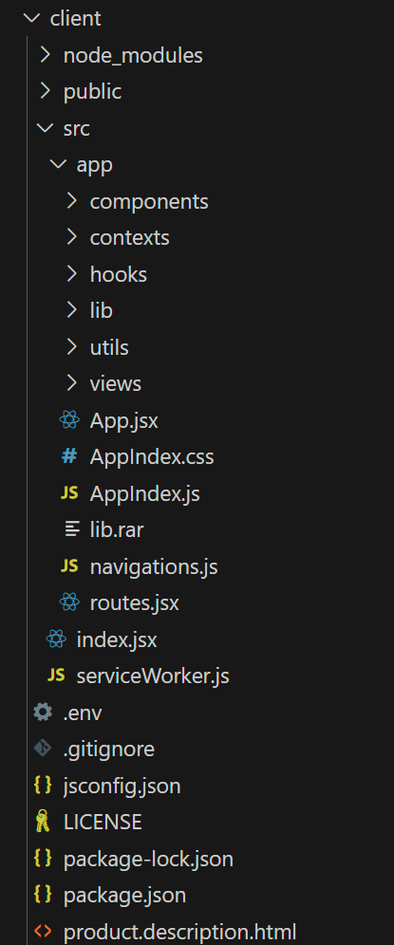

Figure 2. Front-end File Structures

* **public:** This folder holds static assets like images, CSS files, and other resources that are directly served to the browser.
* **src/app:** This directory houses the core source code of my frontend application. It is further divided into subdirectories for better organization:
* **components:** This folder contains reusable UI components that make up your application's interface.
* **contexts:** This folder contain context setting file
* **hooks:** This folder contain use setting file
* **lib:** This folder contains utility functions that are used throughout my application, such as helper functions for formatting data, making API requests, or handling errors.
* **utils:** This folder contains functions that are used to check device and time
* **views:** This folder contains files that represent individual pages or screens of my application. Each page typically consists of a combination of components.

#### 3.2.1.2. Back-end

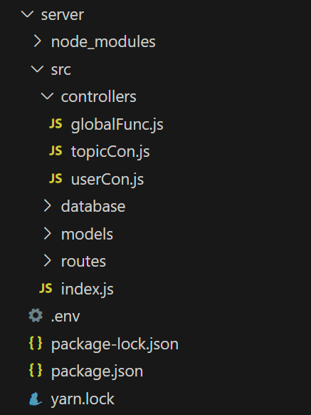

Figure 3. Back-end File Structures

* **src:** This directory contains the core source code of your application:
* **controllers:** This folder holds logic functions that handle specific tasks, such as processing incoming requests, manipulating data, and generating responses.
* **database:** This folder contains configuration files for my database connection, including database credentials, connection strings, and other settings.
* **models:** This folder defines the structure of my data using database schemas. These schemas represent the data entities that my application will store and manage.
* **routes:** This folder maps API endpoints to specific controller functions. It defines the URLs that my application can handle and the corresponding actions to be executed.
* **index.js**: setup server setting

### 3.2.2. Method applied

***Student in charge: Huỳnh Gia Kiện***

Table 3. Method Applied Table

|  |  |  |  |
| --- | --- | --- | --- |
| **No.** | **Method** | **Purpose** | **File name, line number** |
| 1 | EmptyCheck(request)  Input: request  Output: isValid (boolean) | To validate that no keys in the request.body object have empty string values | GlobalFunc.js  (2) |
| 2 | register(req, res)  Input: req  Output: response (success or fail) and a content message | To register a new user | userCon.js  (6) |
| 3 | login(req, res)  Input: req  Output: response (success or fail) and a content message | To authenticate and log in a user | userCon.js  (43) |
| 4 | getAll(req, res)  Input: req  Output: response (success) and user list | To retrieve all users or filter by role | userCon.js  (76) |
| 5 | logout(req, res)  Input: req  Output: response (success or fail) and a content message | To log out a user | userCon.js  (90) |
| 6 | update(req, res)  Input: req  Output: response (success or fail) and a content message | To update user details | userCon.js  (108) |
| 7 | checkAuthen(req, res)  Input: req  Output: response (success or fail) and user information | To check if a user is authenticated | userCon.js  (135) |
| 8 | getDetail(req, res)  Input: req  Output: response (success or fail) and user details | To get detailed user information | userCon.js  (146) |
| 9 | delete(req, res)  Input: req  Output: response (success or fail) and a content message | To delete a user account | userCon.js  (159) |
| 10 | create (req, res)  Input: req  Output: response with all topics or error | Retrieve all topics | topicCon.js  (5) |
| 11 | getAll (res)  Input: none  Output: response (success or fail) and user information | To check if a user is authenticated | topicCon.js  (38) |
| 12 | update (req, res)  Input: req  Output: response (success or fail) | Update details of a topic | topicCon.js  (56) |
| 13 | enroll (req, res)  Input: req  Output: response (success or fail) | Enroll a student into a topic | topicCon.js  (83) |
| 14 | disEnroll (req, res)  Input: req  Output: response (success or fail) | Remove a student from a topic | topicCon.js  (124) |
| 15 | getDetail (req, res)  Input: req  Output: response response with topic details or error | Retrieve details of a specific topic | topicCon.js  (149) |
| 16 | delete (req, res)  Input: req  Output: response (success or fail) | Delete a specific topic | topicCon.js  (162) |
| 17 | approve (req, res)  Input: req  Output: response (success or fail) | Approve a topic | topicCon.js  (173) |
| 18 | checkAuthen(req, res)  Input: req  Output: response (success or fail) | Assign an instructor or reviewer to a topic | topicCon.js  (184) |

## 3.3. Database Design

### 3.3.1. Database design diagram

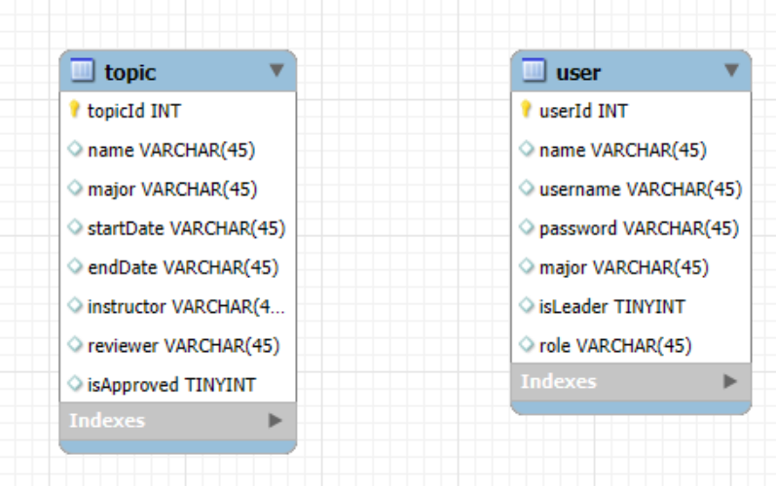

Figure 4. ERD Diagram

### 3.3.2. Tables in the database

Table 4. Tables In The Database Table

|  |  |  |
| --- | --- | --- |
| **No.** | **Table Name** | **Purpose** |
| 1 | User | Store user account information |
| 2 | Topic | Store topic information |

## 3.4. Describing fields in tables

### 3.4.1. User table

Table 5. User Database Table

|  |  |  |  |
| --- | --- | --- | --- |
| **No.** | **Field Name** | **Data Type** | **Purpose** |
| 1 | name | String | Store user’s name |
| 2 | username | String | Store username |
| 3 | password | String | Store password |
| 4 | major | String | Store user’s major |
| 5 | isLeader | Boolean | Clarify user is falculty Dean or Lecturer |
| 6 | role | String | Store user’s role |

### 3.4.2. Topic table

Table 6. Topic Database Table

|  |  |  |  |
| --- | --- | --- | --- |
| **No.** | **Field Name** | **Data Type** | **Purpose** |
| 1 | name | String | Store user’s name |
| 2 | major | String | Store topic’s major |
| 3 | startDate | String | Store topic’s start date |
| 4 | endDate | String | Store topic’s end date |
| 5 | instructor | String | Store topic’s instructor |
| 6 | reviewer | String | Store topic’s reviewer |
| 7 | isApproved | Boolean | Clarify topic is approved or not |
| 8 | students | Object | Store student list of the topic |

## 3.5. User Interface design

Table 7. User Interface Design Table

|  |  |  |  |
| --- | --- | --- | --- |
| **No.** | **UI name** | **Purpose** | **Explain** |
| 1 | Homepage | Show information about the website | For user to have an overview about the website |
| 2 | Login Page | Authenticate users and grant them access to personalized or restricted content. | Protect sensitive information, maintain user privacy, and allow access to specific features based on user roles |
| 3 | Student’s Topic List Page | Show topic lists based on student’s major, show topic’s informations and button to register to the topic | Make sure student can view topic’s informations and register to the topic |
| 4 | Student’s Registered Topic Page | Show student’s registered topic and button to cancel registration | Make sure student can view registered topic’s informations and cancel registration |
| 5 | Lecturer’s Topic List Page | Show topic lists based on lecturer’s major, show topic’s informations and button to register to supervise | Make sure the lecturer can view topic’s informations and register to supervise |
| 6 | Lecturer’s Registered Topic Page | Show lecturer’s registered topics and button to cancel registration | Make sure lecturer can view registered topic’s informations and cancel registration |
| 7 | Dean’s Topic List Page | Show topic lists based on dean’s major  Show topic’s informations and button to register to supervise, button to assign instructor to the topic | Make sure the dean can view topic’s informations, register to supervise and assign instructor |
| 8 | Admin Manage Lecturer Page | Show lecturer’s list and their information  Show button to edit lecturer information or delete lecturer account  Show function to create new lecturer account and assign faculty dean | Make sure admin can manage lecturer’s user accounts |
| 9 | Admin Manage Student Page | Show student’s list and their information  Show button to edit student information or delete student account  Show function to create new student account | Make sure admin can manage student’s user accounts |
| 10 | Admin Manage Topic Page | Show topic’s list and their information  Show button to edit topic information or delete topic  Show function to create new topic | Make sure admin can manage topics |

# Testing

Table 8. Testing Table

|  |  |  |  |
| --- | --- | --- | --- |
| **No.** | **Test case** | **Purpose** | **Explain** |
| 1 | Login with a valid account  Input: account (kien1234, 123456)  Expected result: Login successfully  Actual result: Login successfully  Status: pass | Check that user can login with a valid account | Use an existed account to check |
| 2 | Login with an invalid account  Input: account (kien12345, 123456)  Expected result: Login failed  Actual result: Login failed  Status: pass | Check that user can not login with an invalid account | Use an non-existed account to check |
| 3 | Register to a valid project topic  Input: none  Expected result: Register successfully  Actual result: Register successfully  Status: pass | Check that user can register to a valid project topic | A valid project topic is a topic that not full (3/3) |
| 4 | Register to an invalid project topic  Input: none  Expected result: Register failed  Actual result: Register failed  Status: pass | Check that students can not register to an invalid project topic | An invalid project topic is a topic that full (3/3) |
| 5 | Register to a project topic when student already registered to another topic  Input: none  Expected result: Register failed  Actual result: Register failed  Status: pass | Check that students can not register to a project topic when they already registered to another topic | Make sure that student can only register to 1 topic at a time |
| 6 | Cancel registration of a project topic  Input: none  Expected result: Cancel successfully  Actual result: Cancel successfully  Status: pass | Check that users (student, lecturer, dean) can cancel registration of a topic | Make sure users (student, lecturer, dean) can cancel registration |
| 7 | Register to supervise a valid project topic  Input: none  Expected result: Register successfully  Actual result: Register successfully  Status: pass | Check that users (lecturer, dean) can register to supervise a valid topic | A valid topic is a topic that no one is supervising |
| 8 | Register to supervise an invalid project topic  Input: none  Expected result: Register failed  Actual result: Register failed  Status: pass | Check that users (lecturer, dean) can not register to supervise an invalid topic | An invalid topic is a topic that another user (lecturer, dean) is supervising |
| 9 | Assign reviewer to a project topic  Input: none  Expected result: Assign successfully  Actual result: Assign successfully  Status: pass | Check that deans can assign reviewer to a project topic | Make sure that dean can assign reviewer to a project topic |
| 10 | Approve/Reject a project topic  Input: none  Expected result: Approve/Reject successfully  Actual result: Approve/Reject successfully  Status: pass | Check that deans can approve/reject a project topic | Make sure that dean can approve/reject a project topic |
| 11 | Manage user accounts  Input: none  Expected result: Add/Edit/Delete successfully  Actual result: Add/Edit/Delete successfully  Status: pass | Check that admin can manage (add, edit, delete) user accounts | Make sure that admin can manage user accounts |
| 12 | Manage topics  Input: none  Expected result: Add/Edit/Delete successfully  Actual result: Add/Edit/Delete successfully  Status: pass | Check that admin can manage (add, edit, delete) project topics | Make sure that admin can manage project topics |

# Conclusion

After spending a lot of hard work with enthusiasm, I have completed this project quite well. I could make all basic operations of a project management website work great in spite of some logical conflicts or struggling in handling complex operations. In addition I have also improved coding skills which can help me to work more smoothly in the future projects.

Through this project, I had lots of chances to learn new knowledge about MERN stack.

Besides the results that have been achieved, this website still has many things to overcome and improve with many development directions.

## 5.1. Achievements

* Know the theory of MongoDB, NodeJS, ReactJS, ExpressJS. Learn how to build front-end website and build databases and connect them.
* Project: Project management website with all functions that work well. Including four user types (administrator, student, lecturer, dean). Good interface and easy to use, simple and user-friendly.

## 5.2. Strengths and drawbacks

The website is designed with an easy-to-see and user-friendly interface. In particular, simple operations and functions make users feel comfortable while using the website.

On the other hand, there are still many shortcomings in the design which makes the website not look optimized in components arrangement. Moreover, the website is not so optimized and well-prepared. In terms of functions, due to the lack of expertise and experience, the handling logic and performance are not optimal.

## 5.3. Reflection

After completing this project, I feel how small I am in this huge technology world, there are enormous things to learn, to fulfill and to archive in the future. I could also understand more how hard it is to build just a basic website, which I thought would be quite easy in the past. Overall, this project has enlightened me about how big this IT world is and will be in the future.

## 5.4. Future developments

* Responsive website.
* Improve website performance.
* I will work to improve the website and add more features in the future.
* Enhance the user interface and experience.

# References

*Nabed Khan. (2024). Uilibrary/matx-react: Matx -free and open-source react material UI admin dashboard template. GitHub.* [*https://github.com/uilibrary/matx-react*](https://github.com/uilibrary/matx-react)

*Meta Platforms. (2024). React. React.*[*https://react.dev/learn*](https://react.dev/learn)

*OpenJS Foundation. (2024). Node.js v21.4.0 documentation. Node.js.*[*https://nodejs.org/docs/latest/api/*](https://nodejs.org/docs/latest/api/)

*Material UI SAS. (2024). Overview - Material UI. MUI: The React component library you always wanted.*[*https://mui.com/material-ui/getting-started/*](https://mui.com/material-ui/getting-started/)